Research Question
What is the average speed of some arbitrary object as it moves along a track?

Diagram
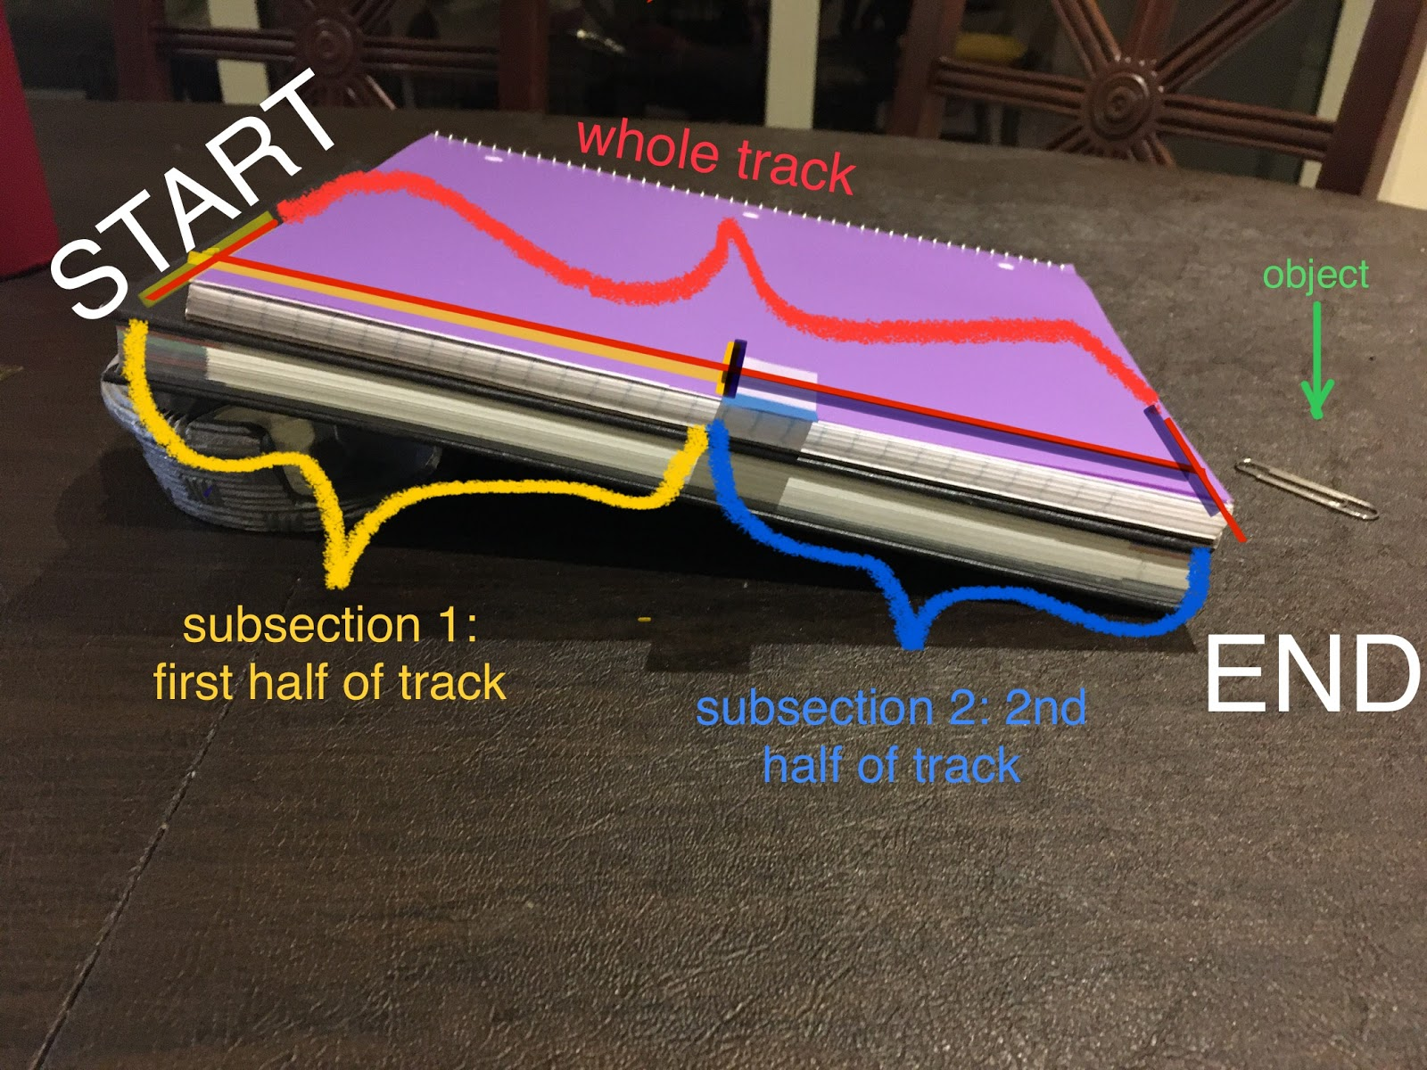

Analysis
The track was displayed using a notebook and an object to create an incline plane in order for the object to move along the track. Based on the time it took for the object to travel the whole track, the average speed will be determined with the following measurements conducted in distance and average time (see Appendix B for Equations/Formulas).
Since the unit of length is a pen and the unit of time are snaps, the experiment was performed for three trials (see Appendix A for values collected). This will allow us to use the following calculation:

Average Speed = Total Distance / Change in Time

The average speed can only be calculated once the total distance of the track is measured and the time it took for the object to travel. Notice that the first half and second half of track will have to be measured as well using the same formula but distance will be half. Total Distance units are pens and time are snaps so the units for average speed will be the number of pens / snaps (see Appendix C for calculations) which can be perform as:

Average Speed = 2.52= 1.25 pens / snaps

Uncertainty

Appendices
Appendix A:
Unit of Length: Pen
Sub Unit: Eraser (2 erasers in one pen)
Unit of Time: Snaps
Trip | Distance (pens) | Time (snaps) |  |  |  | Avg. Speed (pens/snaps)
Whole Track | 2.5 | Trial 1 | Trial 2 | Trial 3 | Avg. Time | 2.5/2 = 1.25
Whole Track | 2.5 | 2 | 2 | 2 | 2 | 2.5/2 = 1.25
1st Half of Track | 1 | 1 | 1 | 1 | 1 | 1/1 = 1
2nd Half of Track | 1 | 1.5 | 1 | 1 | 1.17 | 1/1.17 = 0.85

Appendix B:
Equations/Formulas:
Average Time = Sum of Values / Number of Values
Average Speed = Total Distance / Change in Time

Appendix C:
Calculation:
Average Time
Whole Track: 2+2+23= 2 snaps
1st Half of Track: 1+1+13= 1 snap
2nd Half of Track:1.5+1+13 = 1.17snap
Average Speed
Whole Track: 2.52= 1.25 pens/snaps
1st Half of Track: 11= 1pen/snap
2nd Half of Track: 11.17= 0.85pen/snaps

Appendix D:
Uncertainties:
1 pen (smallest unit) = 2 erasers (subunit ±0.5)
1 pen 2 erasers*0.5 erasers= ±0.25 pen (uncertainty)

1 snap (smallest unit) = ±0.5 snap (uncertainty

